**DNS**

Domain name system is a system that translates human friendly hostnames into machne IP addresses.

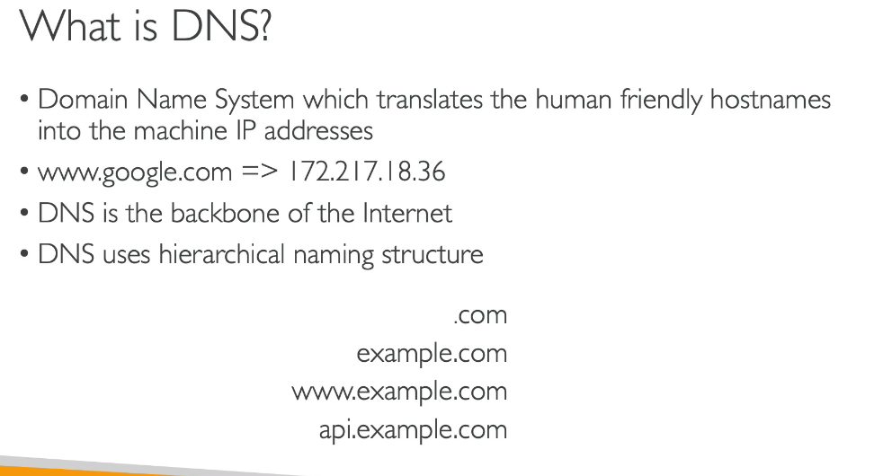

**DNS TERMINOLOGIES**

**Domain Registrar:**

**Dns Records**

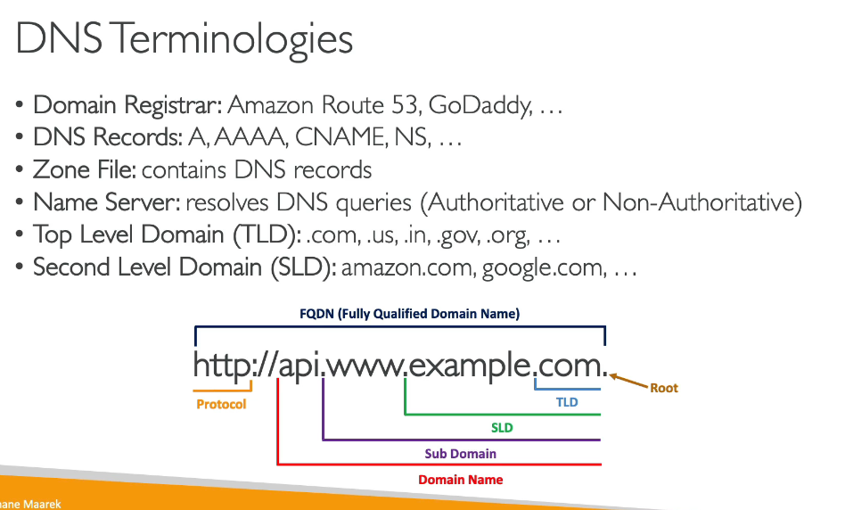

HOW **DNS WORKS**

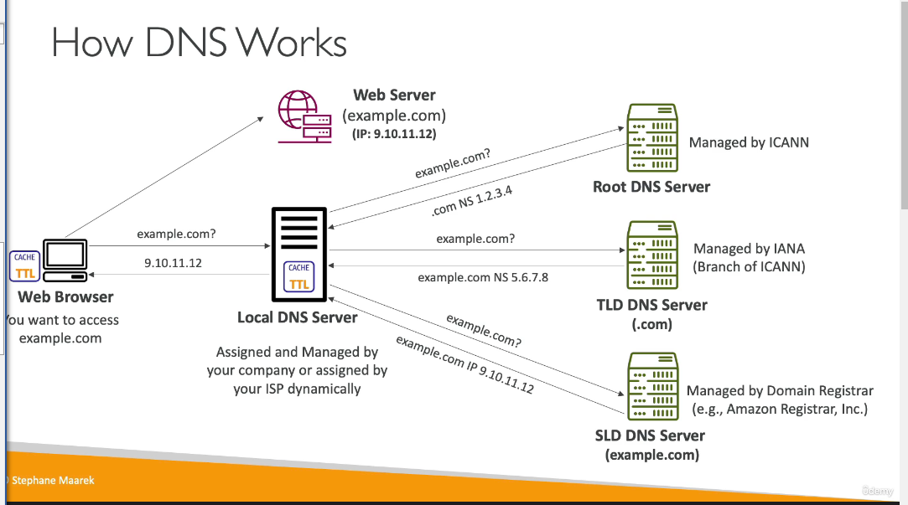

1.webserver example.com is an ec2 instance.Our web browser wants to access it .

2.our web browser will send arequest to the local dns asking if it knows example.com

3.local dns goes to root dns which gives ip of tld ie .com

4.now the tld gives address of sub leel domain dns which is example.com which is turn will return an ip address which will be returned to our web browser so that it can access the example.com web server.

**AMAZON ROUTE 53**

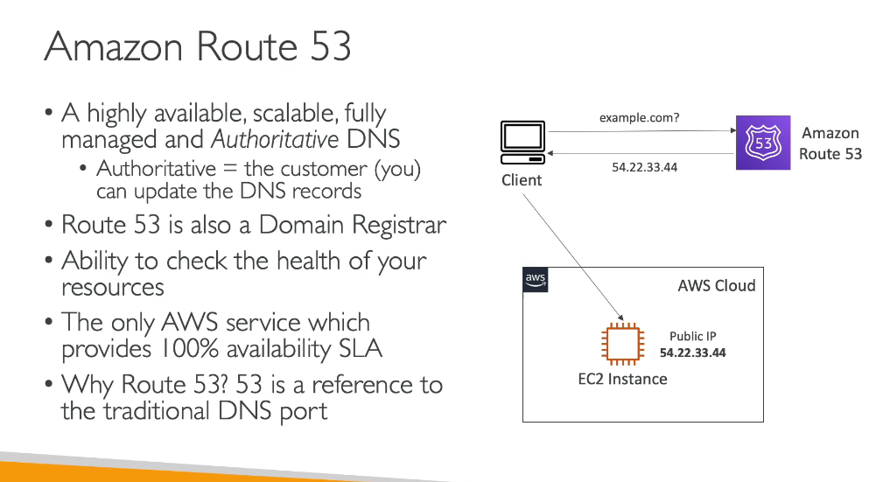

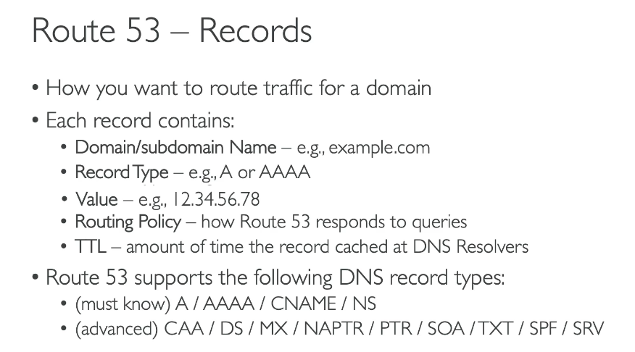

**IMPORTANT RECORD NAMES**

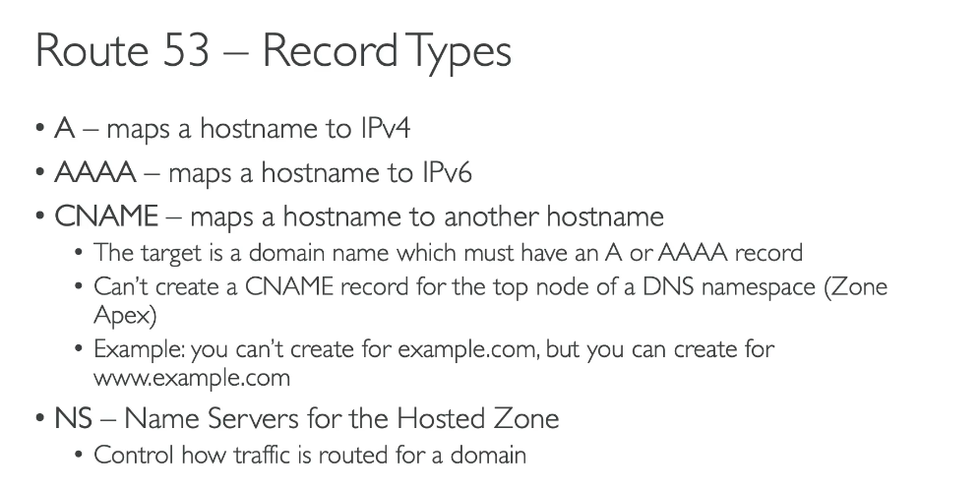

HOSTED ZONES

A hosted zone is a container for records that define how to route traffic to a domain and its subdomains.

There are two types of hosted zones:

1.public hosted zones

2.private hosted zones

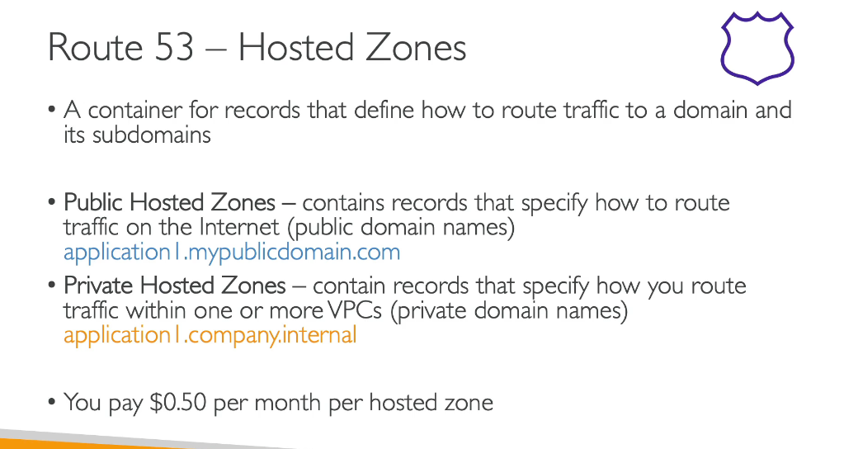

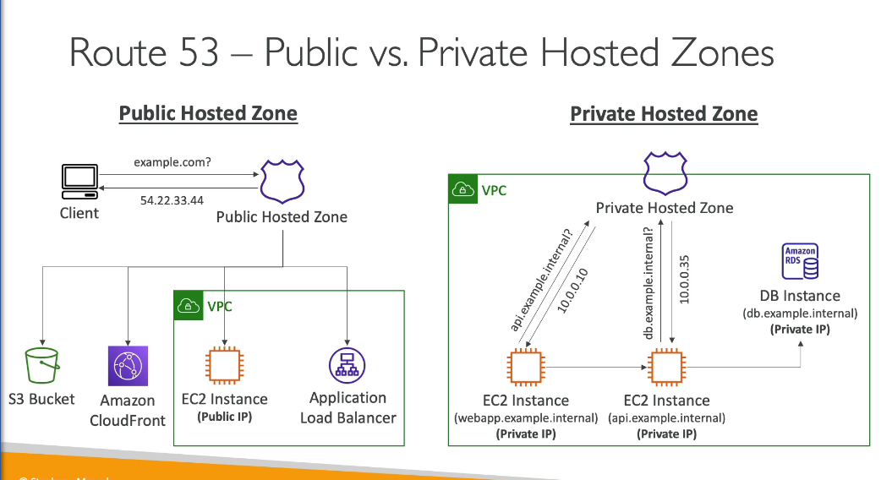

**REGISTER A DOMAIN**

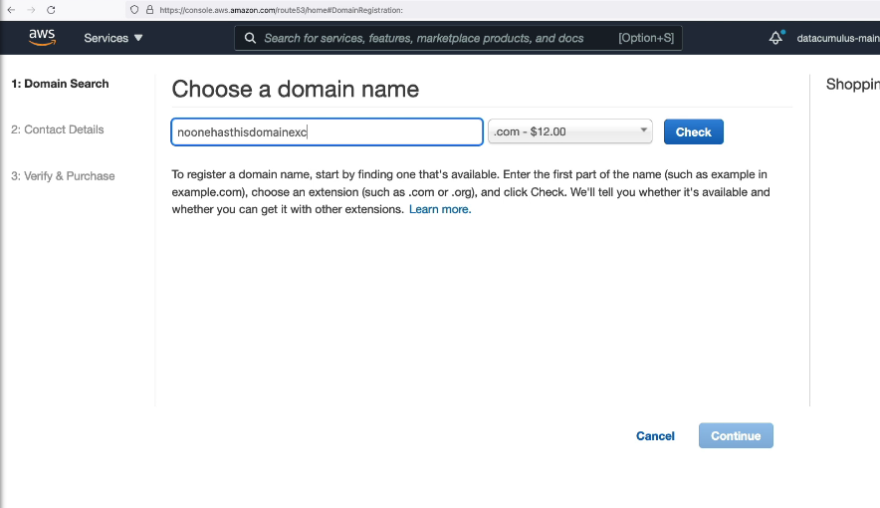

we need to check for availability of a domain name.

then we need to specify contact for our domain

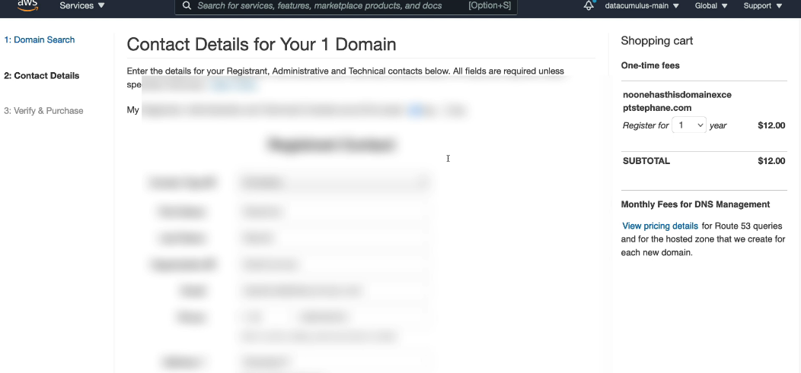

Then enable the privacy protection. Privacy protection hides some contact details for .com domains hence you will be saved from spammed by anyone.

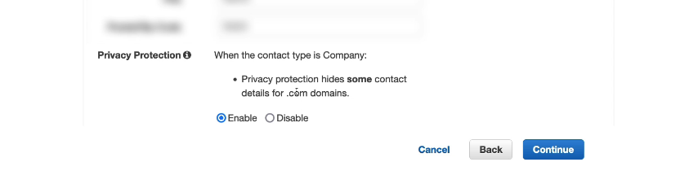

Once this process is done your domain is ready.

(A domain is a [network](https://www.webopedia.com/definitions/network/) of [computers](https://www.webopedia.com/definitions/computer/) and [devices](https://www.webopedia.com/definitions/device/) that are controlled by one set authority and have specific guidelines. More specifically, a domain is controlled by one particular company that has its own internet presence and [IP address](https://www.webopedia.com/definitions/ip-address/). The domain is labeled by its [domain name](https://www.webopedia.com/definitions/domain-name/), such as Webopedia or webopedia.com.)\\

A host zone is created as shown below:

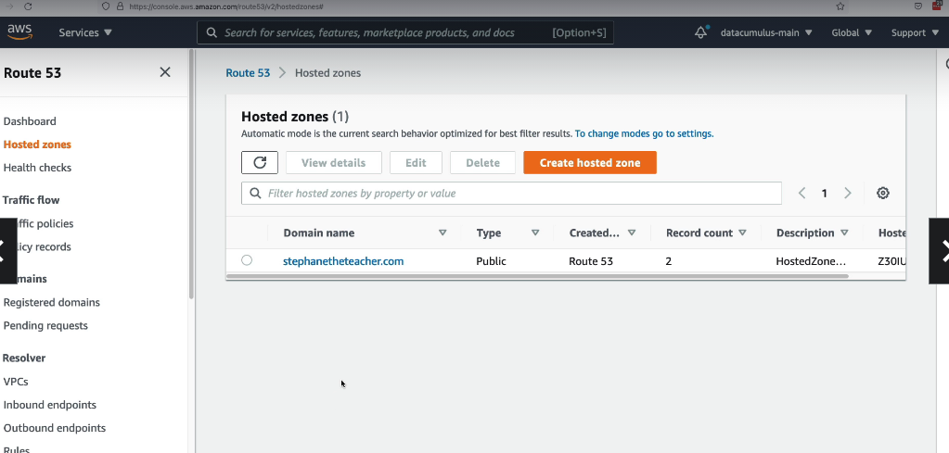

**CREATING OUR FIRST RECORD IN ROUTE 53**

First we need to go into our hosted zone.

As above it is “stephaneteacher.com”

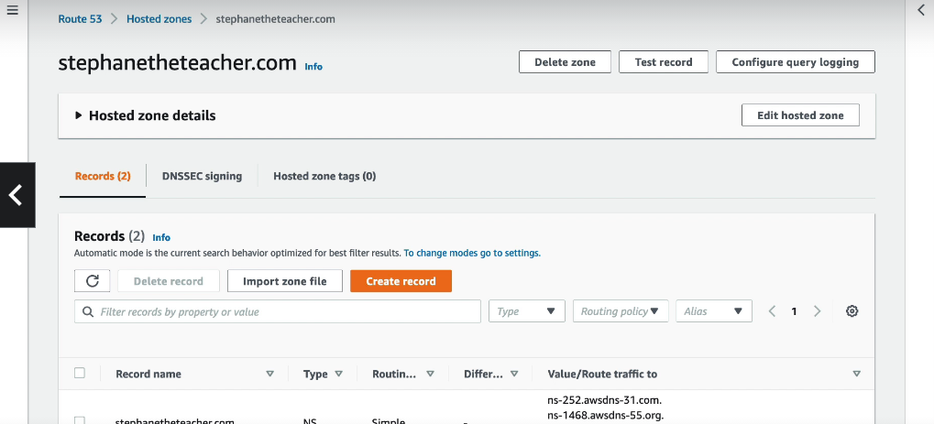

We click on create record

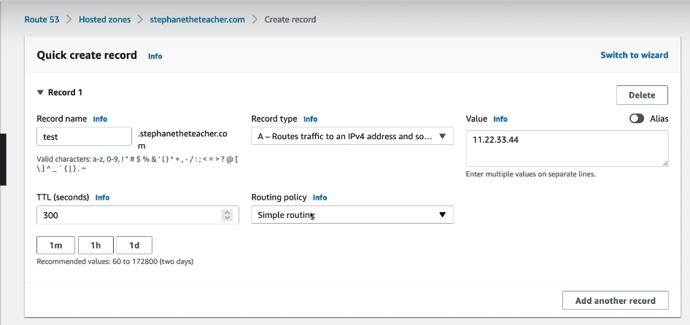

We will create a record as above.we will give the record name and then where it needs to route to means to which ip it needs to route to.

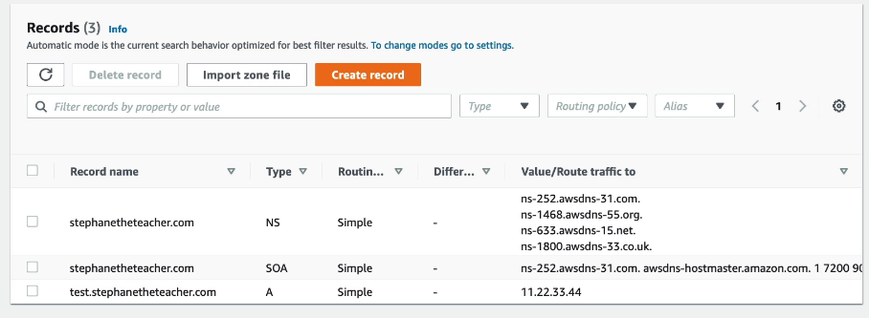

Now the record is created.Now if we go to browser and type text.stephaneteacher.com the browser will go to our hosted zone and ask the ip address and then our hosted zone will return the ip address to route to.

**Steps:**

Now we open the cloudshell and then do for nslookup

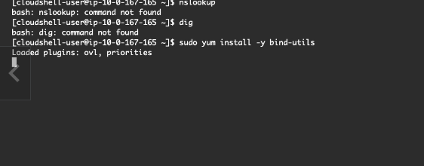

After updating when we do nslookup

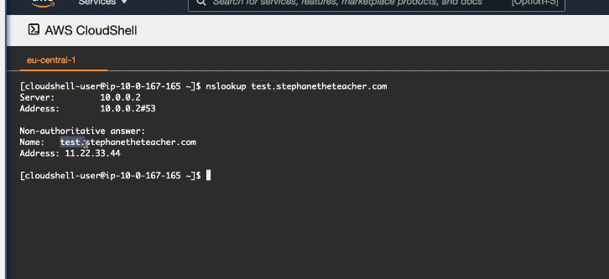

**ROUTE 53 EC2 SETUP**

We will launch 3 ec2 instances in 3 different regions suppose 1 in Bombay,other in frankfrut and last in Tokyo.

2.Now we will create an application load balancer which in the target group will have any of the above on ec2 insatnec as a target.

We just check to connect to each ec2 instance from our browser and check if it is responding or not.

**RECORDS TTL(TIME TO LIVE)**

By time to live it means that a client will make a request to the dns/route 53 to tell about the ip of dn it is looking for so there will be a ttl set so that the user need not to access dns again and again rather it can get the ip from its local cache only thus saing time and heavy traffic on route 53.

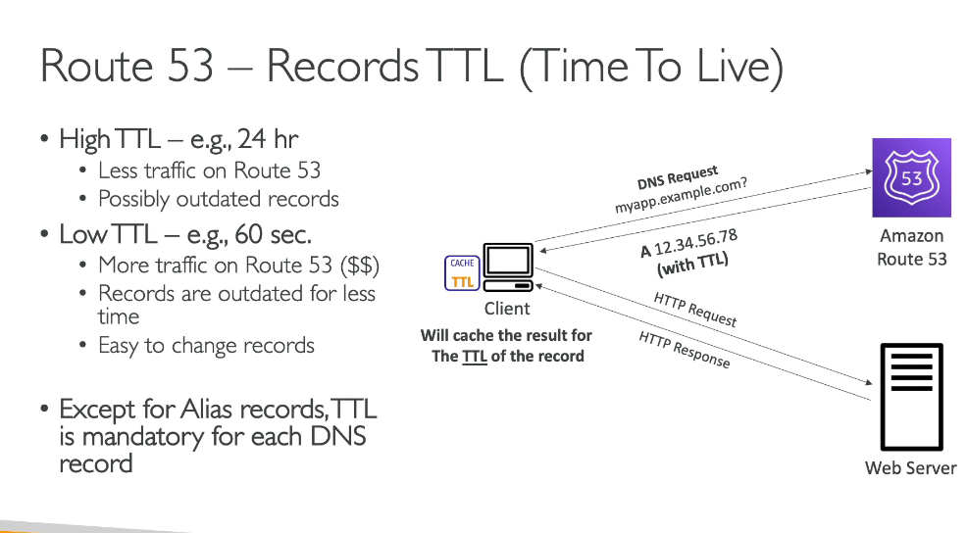

**LETS SEE HOW TTL WORKS FROM THE AWS CONSOLE**

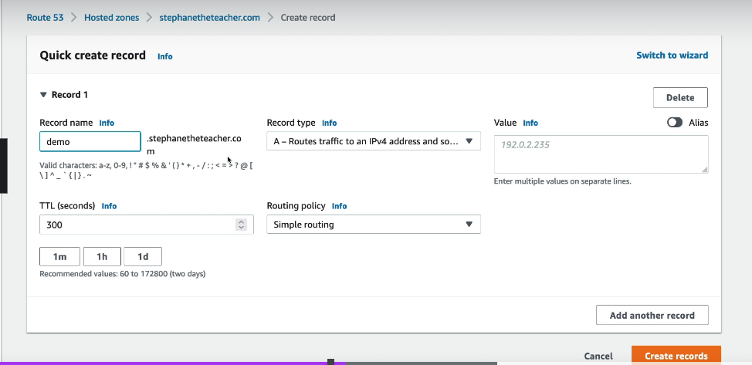

First we will create a record.

We have created a record which is pointing towards one of our ec2 instance and its time to live is 2 minutes.

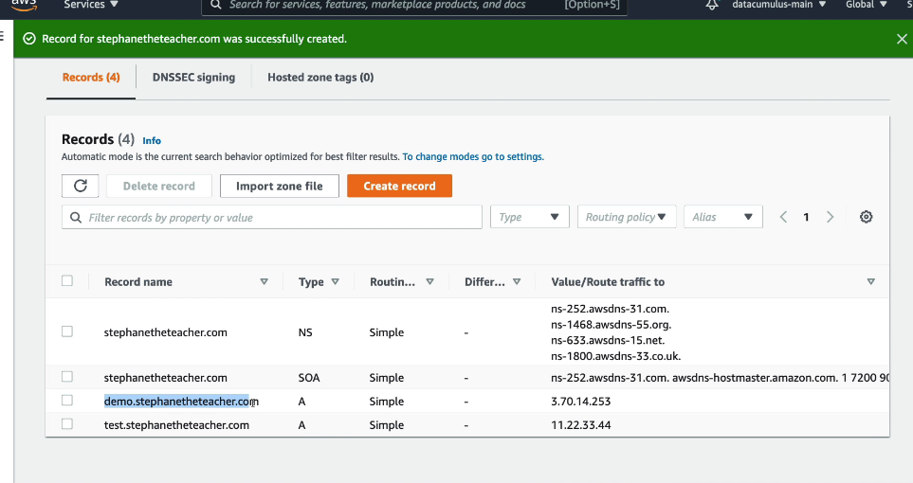

We try to open the above record.

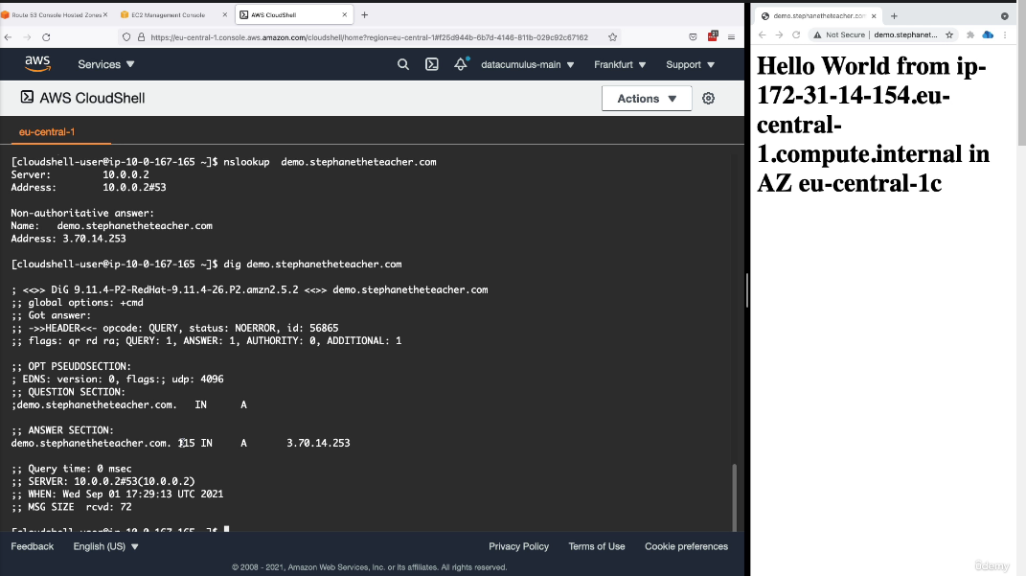

When we try to reach out to this record agiin it will be fetched very quickly because it has been cached on our system for 2 minutes.

If we change the underlying ec2 istance in the span of 2 minutes then the request will still go to our cached data only and will only get updated after 2 minuets.

**CNAME VS ALIAS**

When we have an aws resourde then it has a hostname which is provided by aws itself but we want to access it with some other hostname so we give it an alias or a cname.

**1.CNAME points a hostname to another hostname**

**2.Alais points a hostname to an AWS resource.**

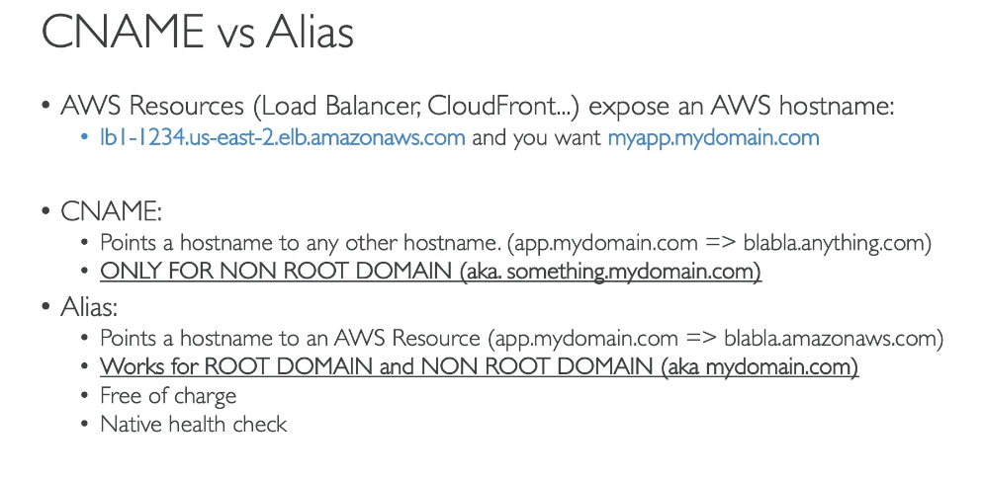

**How alias records work**

Alais maps a hostname to an aws resourse.When there is a change in the resource ip address it automatically recognizes it.it can be used for the top node of a dns name i.e. example.com

You cant set the ttl of an alais record it is set by default.

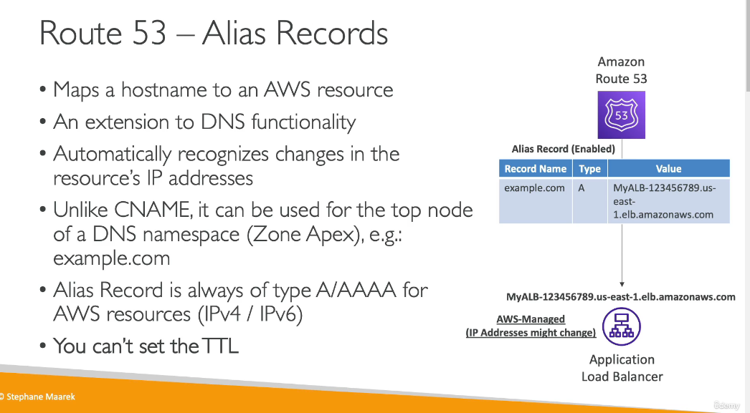

**Alias records targets**

The following are the targets for an alias record.But one think we need to remember is that we cannot seta n alias for an ec2 dns name**.

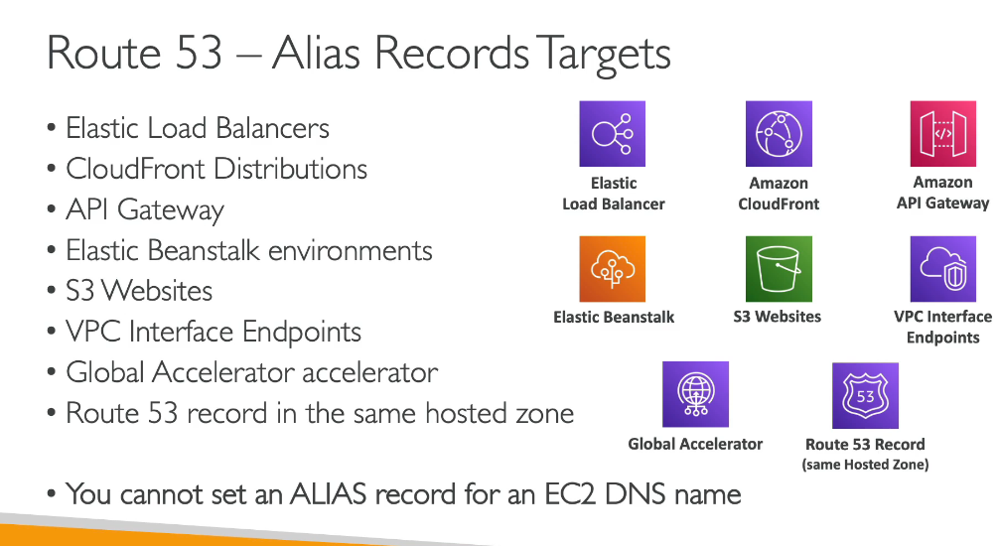

**CREATING A CNAME RECORD.**

If we want to create a cname record then we wil have a record name and make it point to some other record as shown below:  
our record will point to alb which means when we try to access myapp.staphane.com then it will redirect us to the alb.

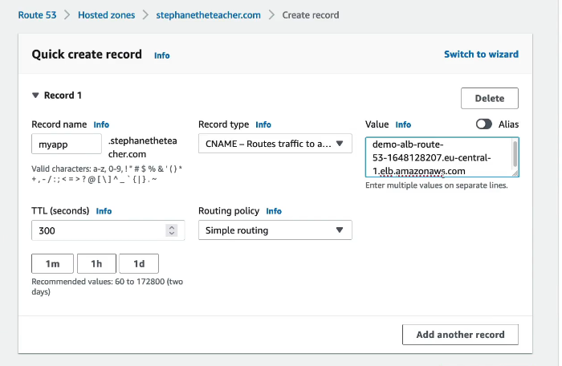

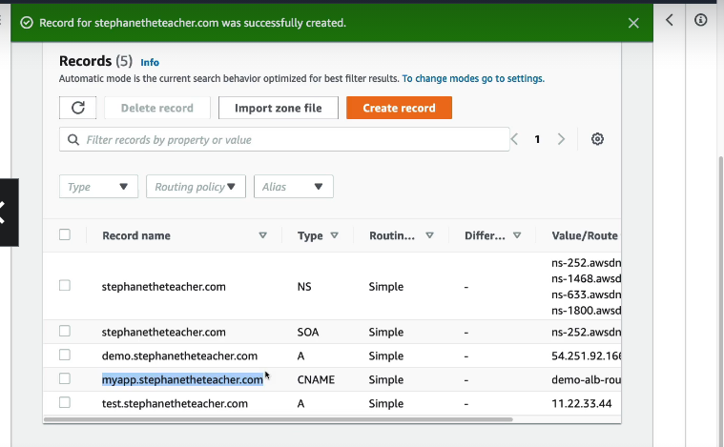

Now we access with tis cname .

**CREATING AN ALIAS RECORD**

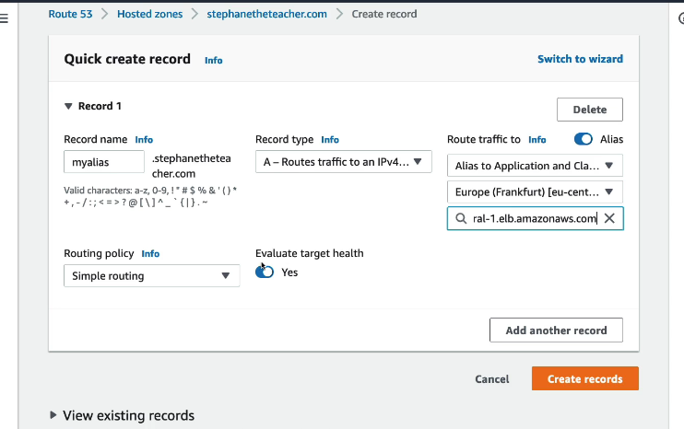

We need to specify it as A type record.

It is going to route traffic to an application load balancer then we choose the region and then select our alb.

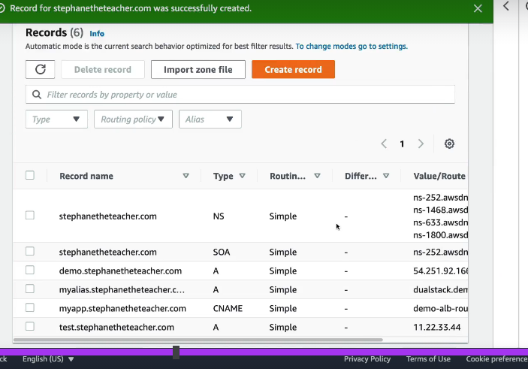

**THE DOMAIN APEX**

We want only stpahneteacher.com to an alb so we do the below steps:

CNAME WILL NOT WORK BUT ALIAS WILL

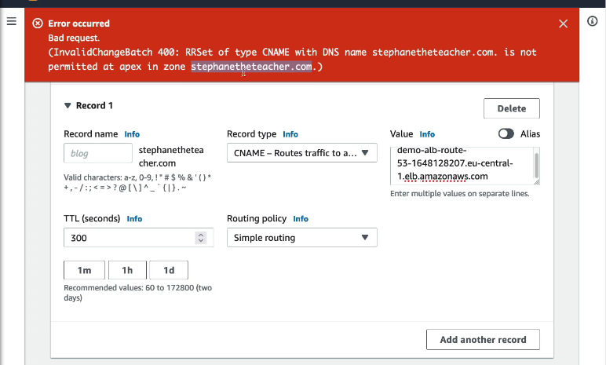

Now an alias record will be accepted in this case.

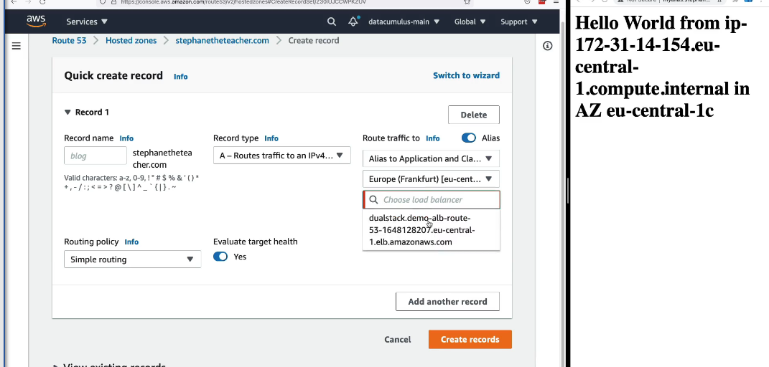

**ROUTING POLICY IN ROUTE 53**

The routing poilicies define how route 53 responds to dns queries.The routing here signifies how the queries of a request are resolved and how the ip address of a request is returned.

A dns does not route traffic it only responds to the dns queries.

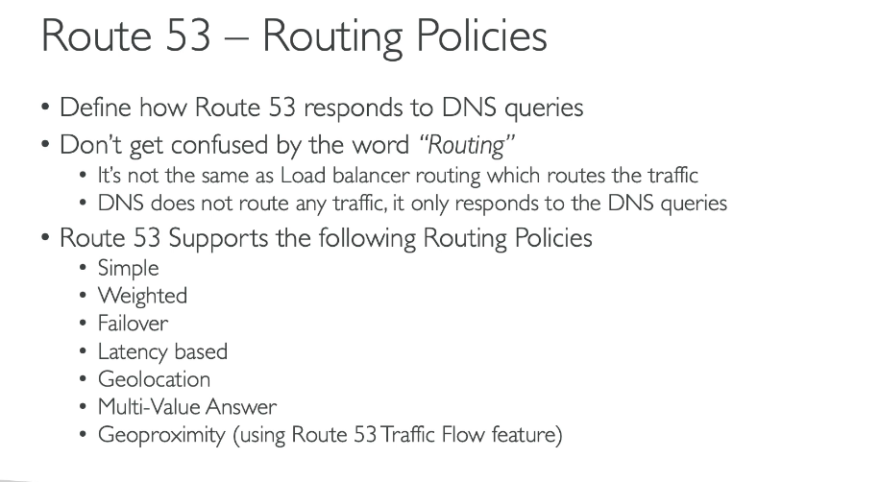

**1.SIMPLE ROUTING POLICY**

A simple routing policy simply routes traffic to a single resource.

We can specify multiple values in the same record and if multiple values are returned by dns then any random value is chosen by our client.

They cant be associated with health checks

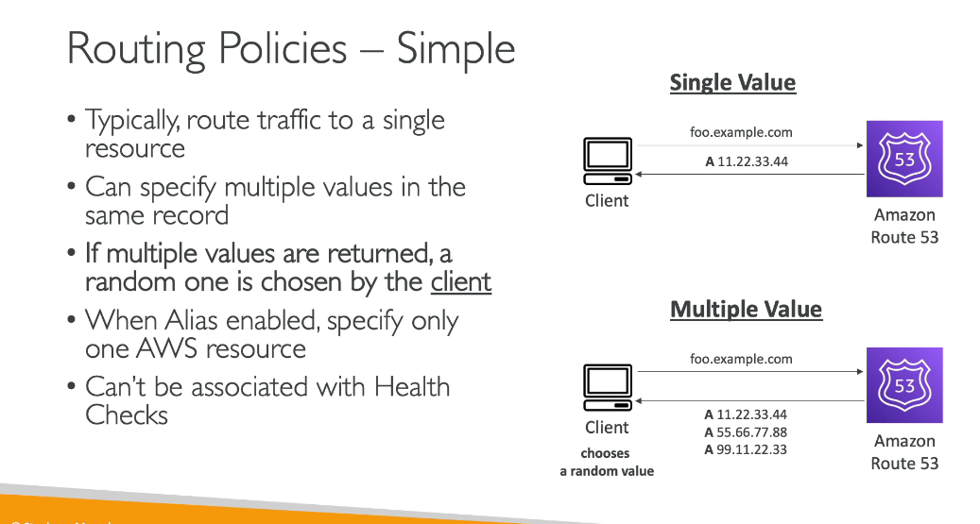

We can make a simple record by just creating a record and annding the ips whichever required.

**2.WEIGHTED ROUTING POLICY**

In the weighted routing policy we assign weights to each specific resource according to which that amount of percentage of traffic goes to that machine.

The weights of all machine do not need to sum upto a 100.

All the dns records must have the same name and type and they can be associated with a health check.

Use case:  
1.It involves load balancing across regions

2.Testing the different version soif a new application by keeping them on different ec2 instances.

**If we want to stop sending traffic to a particular ec2 instance then we can mark that instance with a zeroi weight.**

**If all records have a zero weight then the traffic will be equally distributed.**

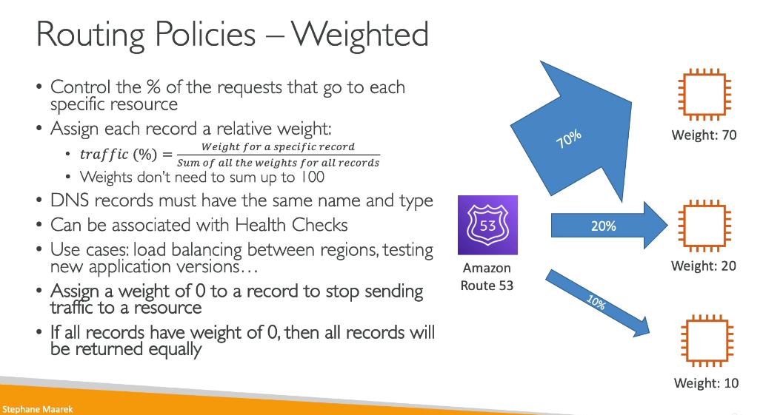

**CREATING A WEIGHTED RECORD.**

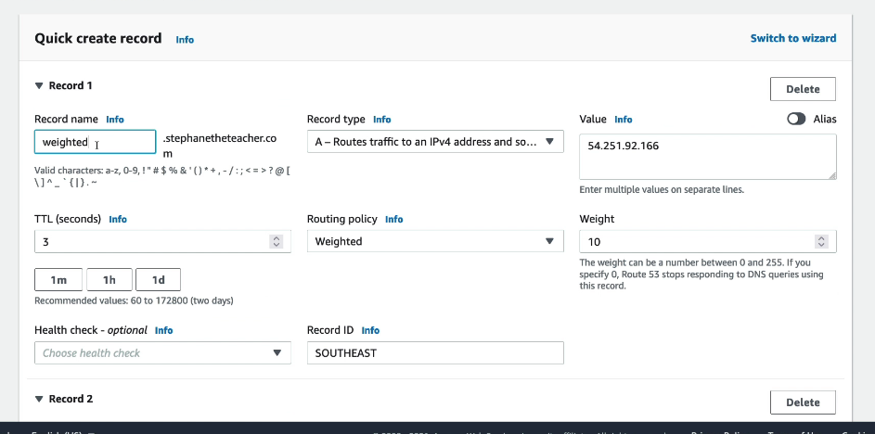

In the similar manner as above we will create different record by keeping on adding new records and assigning weights to them.

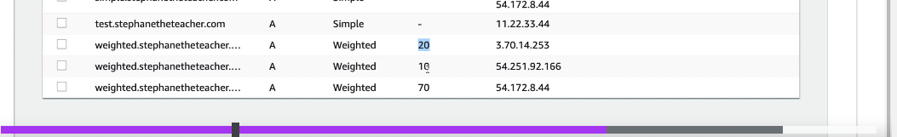

**3.LATENCY BASED ROUTING POLICY**

In the latency based routing we need to redirect to the resource that has the least latency close to us.Super helpful when latency for users is a priority.’ 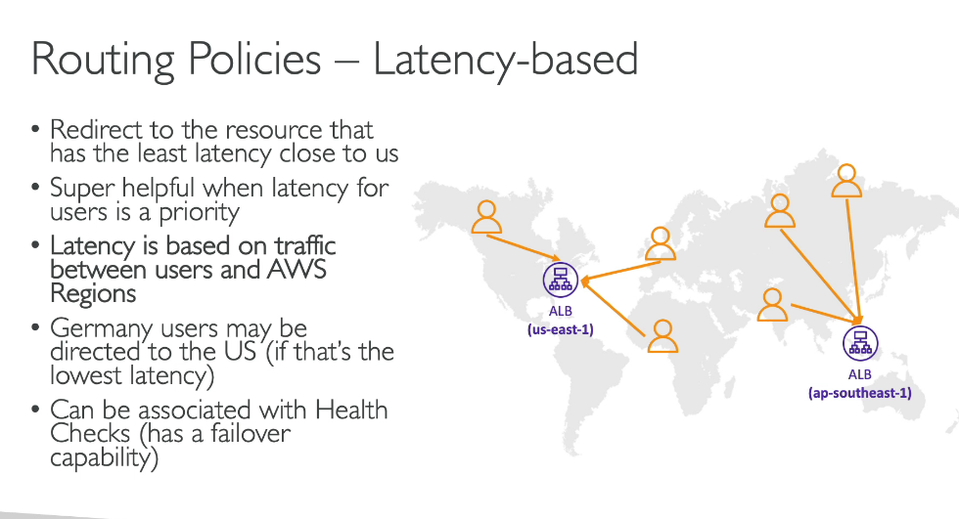

**HOW TO CREATE A LATENCY BASED ROUTING POLICY**

For creating alatency based routing policy suppose we have three ec2 instance sin some regions and we create records for them as shown in screenshot below:  
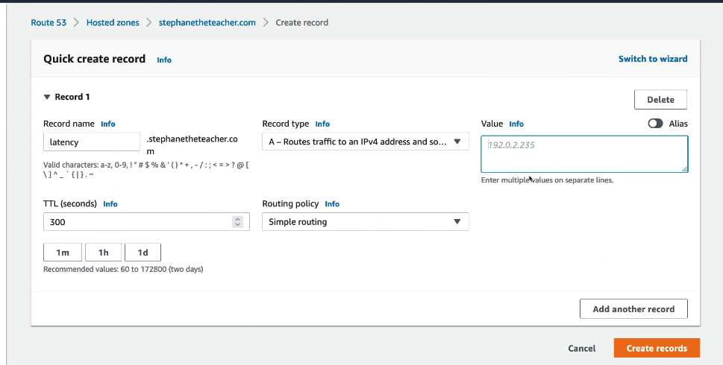

So as above wewill enter our all the regions with ec2 in this record and then when we try to reach out to our ec2 instance then the one which will be the closest will be queried first of all due to the least latency.

**ROUTE 53 HEALTH CHECKS**

A healthcheck works as below.HTTP health checks are only fro public resources.

We don’t want our traffic to be routed to some resource whose health is not ok.SO we have two alb which are pulic facing and we have setup healthchecks for them.

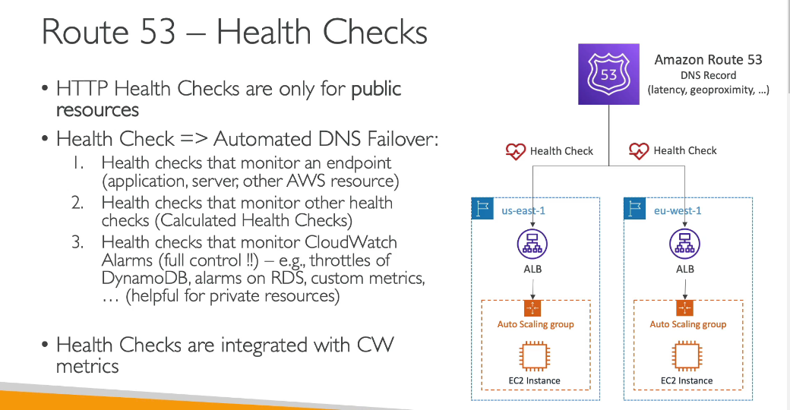

**HELATH CHECKS HO DO WE MONITOR AN ENDPOINT**

We have many health checkers suppose 15 in this case that will check the endpoint health.

If some of the healthcheckers respond that an endpoint is healthy then it is meant to be healthy and traffic is routed to it or some of the conditions are as specified below:

And we need to keep a check that our alb is allowing incoming traffic from the route 53 health checkrs.health cehcks are only meant to pas only when the endpoint responds with a 3xx or 2xx status code.

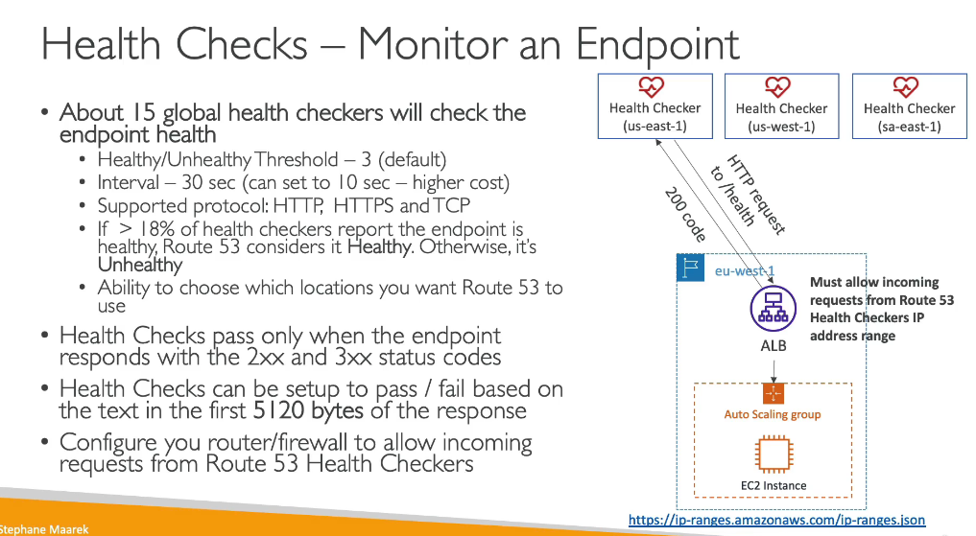

**CALCULATED HEALTH CHECKS**

These are the second type of health checks.in this we combine the health check of various health checks.

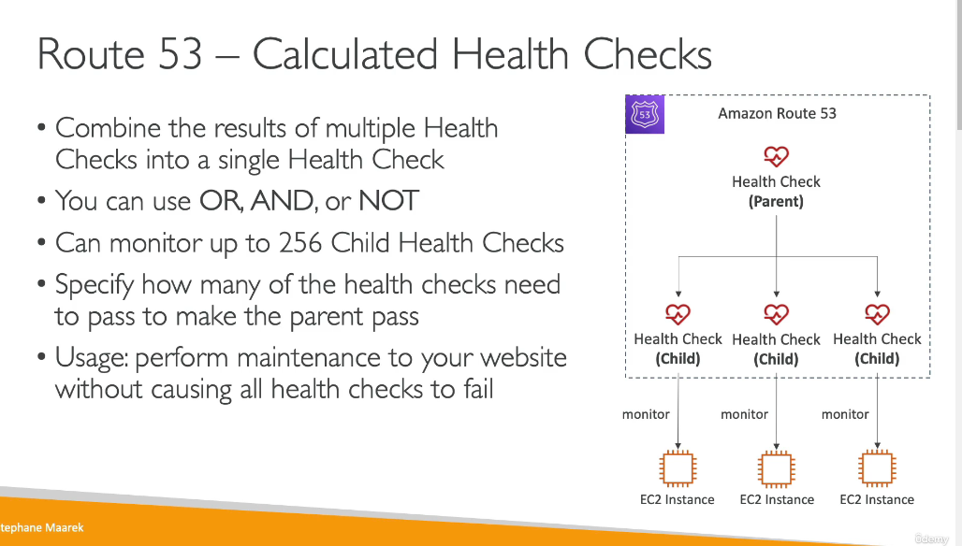

**HOW TO MONITOR HEALTH OF PRIVATE RESOURCE**

In this case we have a ec2 instance in a private subnet which cannot be accessed publically.So in this case we will set a cloudwatch alarm so whenever our instance is breached then the alarm will be triggered and our healthchecker will keep a check on the cloudwatch alarm which in turn will specify whether an instance is healthy or not. 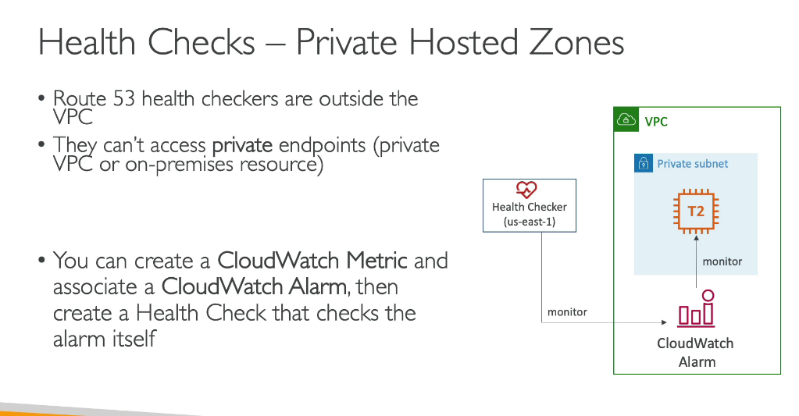

**CREATING A HEALTH CHECK**

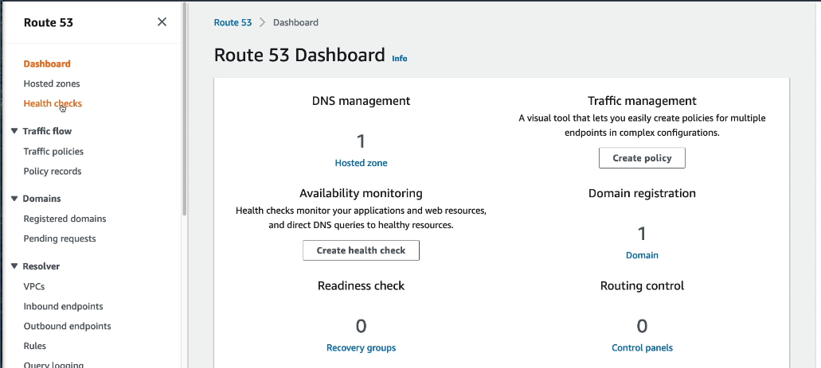

First go into the healthcheck on the left hand side dashboard

After this we will create our first healthcheck in which we will specify the various conditions and also the ip address of instance it is associated with.

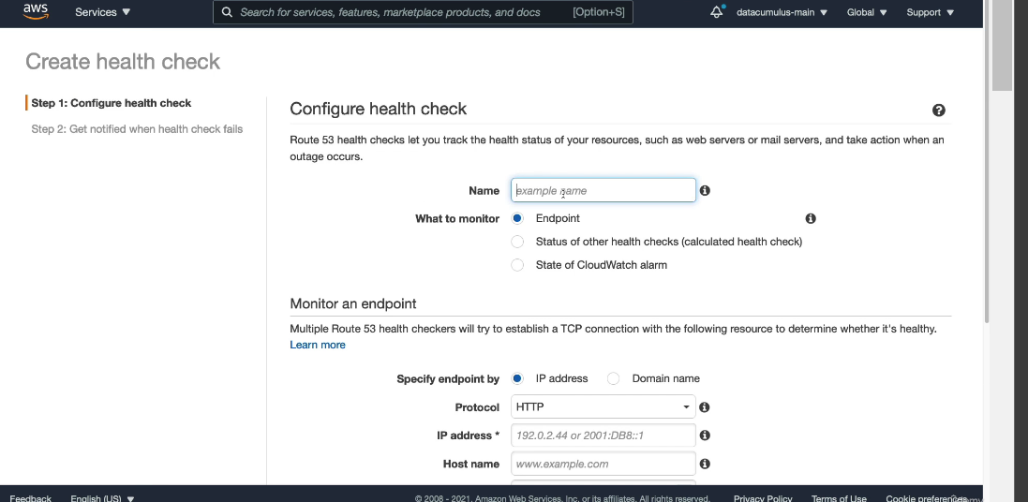

After configuring all these healthchecks we will check the status of eash record.

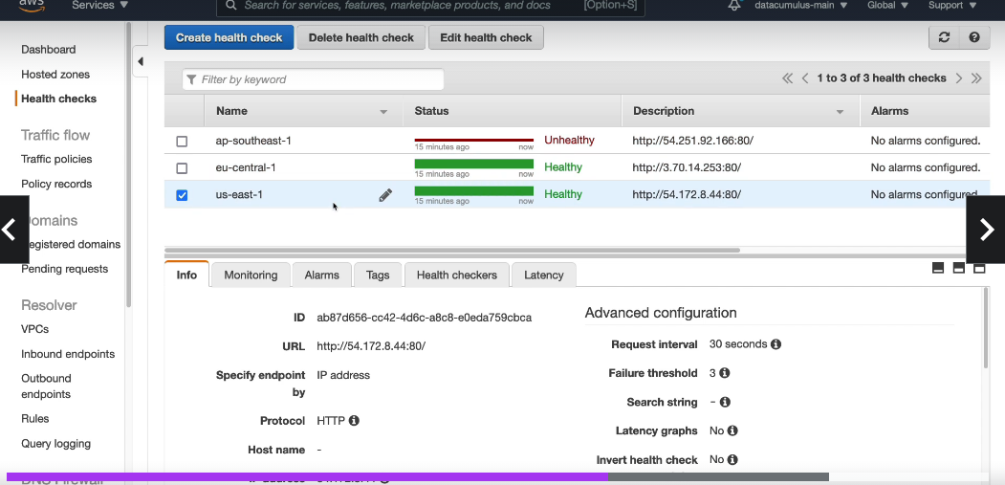

One of them is being deemed as unhealthy as we have blocked port 80 odf that instance from where a request to check the health was being sent.

**Calculated parent healthcheck**

This healthcheck is created by selecting the status of health check endpoints so that it keeps a check on the other underlying ec2 instances in this we will specify condition that atleast one of these resources must be deemed healthy then we can say that the sattus is healthy else if two return not health then mark as not healthy as in this case we can have a huge traffic which can come nd we may face many failover sta that time.

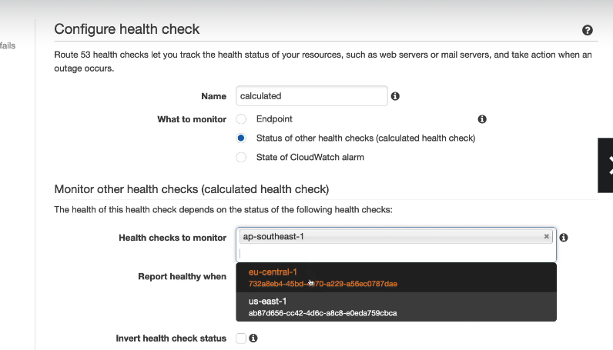

The last kind of health check be to measure the performance of a cloudwatch alarm which in turn istaking care of the underlying private ec2 instance.so in this case we need to pecify the region in which our cloudwatch alarm is.

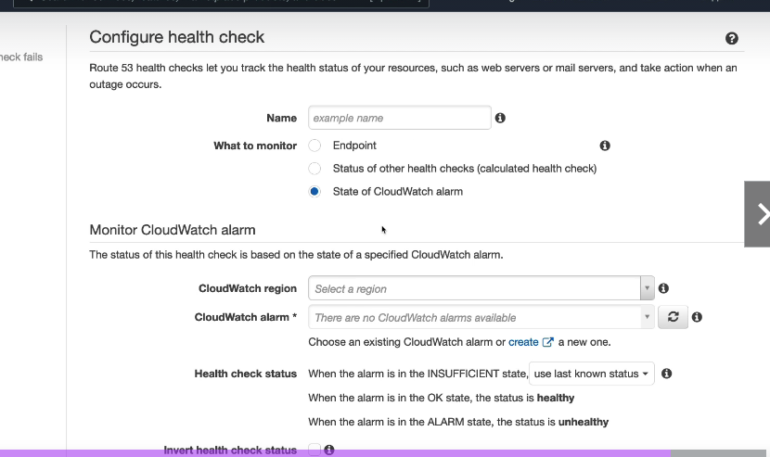

**ROUTING POLICY-FAILOVER(ACTIVE-PASSIVE)**

We have two ec2 insatnces one is a primary instance and the other is a secondary -disaster recovery instance.SO in this case setting is mde in such a way that there is a mandatory healthcheck for the primary ec2 instance and in case when the primary is deemed unhealthy then the request goesto the secondary instance an the client is sent the response of whichcever instance is deemed healthy at that moment. 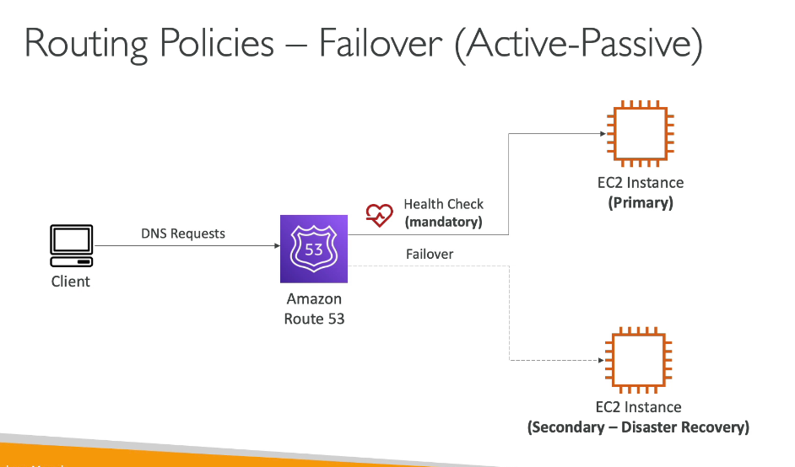

**How do we create a failover healthcheck**

We will create a failover by creatinga record such that there is going to be a primary record which is redirecting to the ip adress as mentioned in the value textbox and a healthcheck will be associated with it which will check the health of this instance and will route to the other secondary instance when this on eis deemed unhealthy

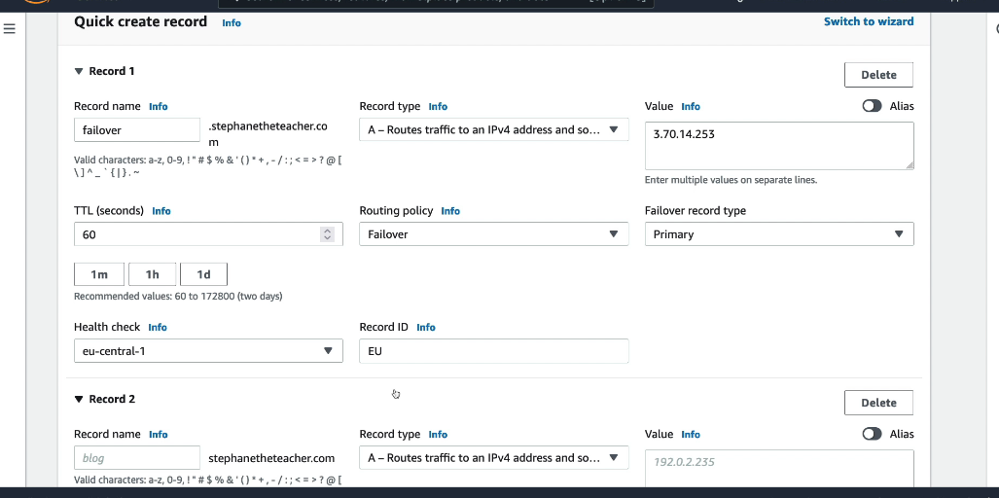

**ROUTING POLICY-GEOLOCATION**

Based on where a user is geographically located

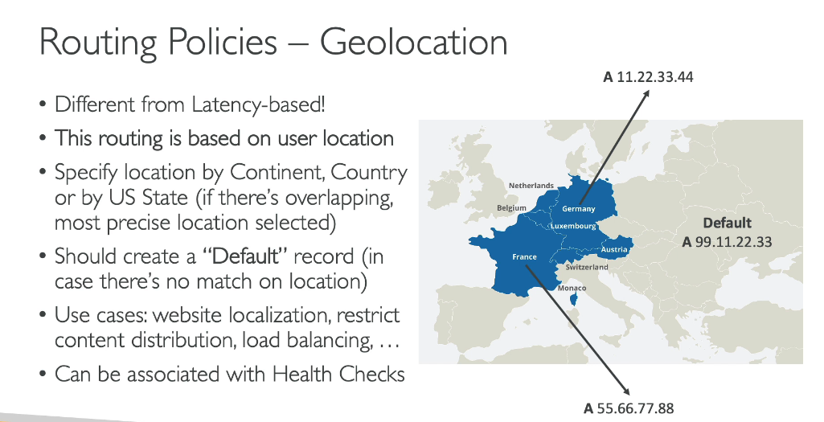

In this the geolocation of a person will be seen as all the people in Germany to be routed to the A record where my website is in german language and people in France to be redirected to France location ec2 instance an dthere must also be a default routing which specify if a geolocation is not bale to be decided then move the traffic to this location.

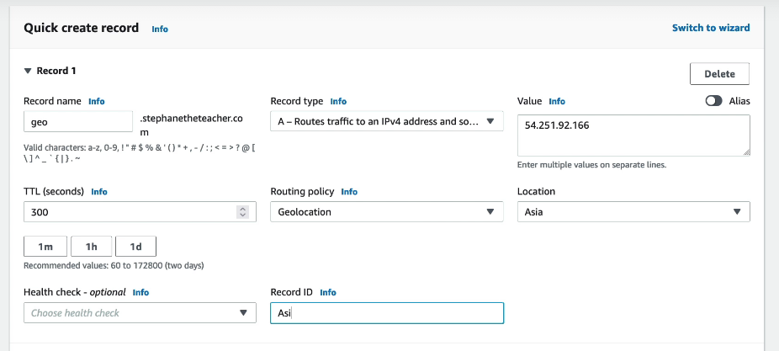

All the people in asia should be sne dtoipvalue as shown above..

And also we can specify as a default as below:

**ROUTING POLICY-GEOPROXIMITY ROUTING**

In this type pf routing we route on the basis of the geographic location of the users and resources.There is an ability to shift more traffic to resources based on a defined bias.i

If we want more bias then we ca expand a bias value and if we want low bias we can decrease the bias value.

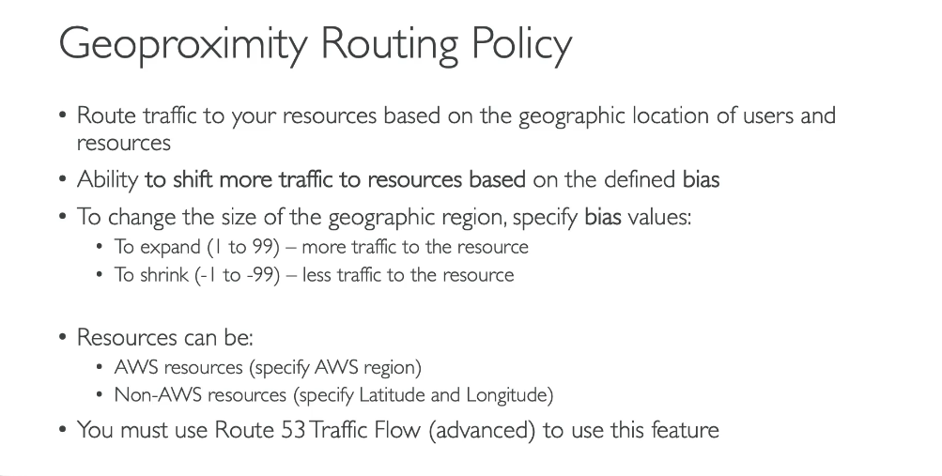

**No bias**

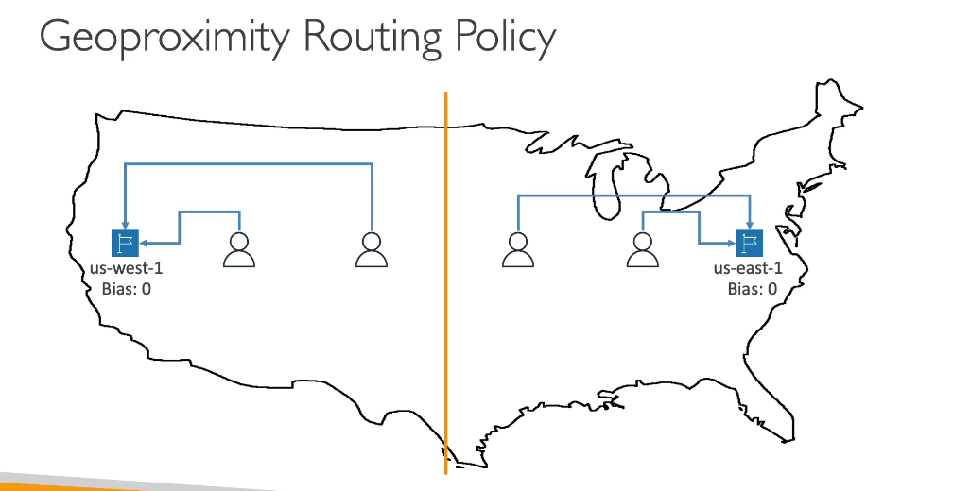

**With bas**

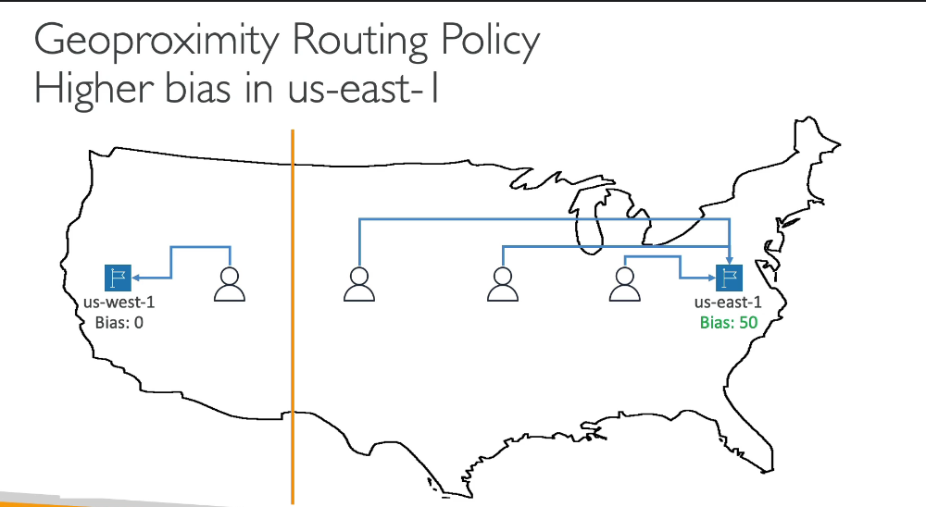

This has a use case in which we have two resources deployed in a region and we want more traffic to be dragged to one instance so in this case we will be using a geoproximity routing policy in which we will give more bias to one we want more traffic to be routed to .\

**TRAFFIC FLOW**

THIS is atechnique used in the traffic flow in the geoproximity routing type.

